***Modern Agricultural Technology Its Importance And The Way Of Modernization Of Farming Style- (A REVIEW)***

1st Shykat Roy  
 *School of Computer Science and Engineering*

*Lovely Professional University Jalandhar ,India*  
[shykatroybdku199@gmail.com](mailto:shykatroybdku199@gmail.com)

4th Pronoy Kumar Dey  
 *School of Computer Science and Engineering*

*Lovely Professional University Jalandhar ,India*  
[pronoykumardeylpu@gmail.com](mailto:pronoykumardeylpu@gmail.com)

2nd M Bhanu Prasad  
 *School of Computer Science and Engineering*

*Lovely Professional University Jalandhar ,India*  
[bhanuprasadmiryala32@gmail.com](mailto:bhanuprasadmiryala32@gmail.com)

Krishna Bansal (Asst. Professor)  
 *School of Computer Science and Engineering*

*Lovely Professional University Jalandhar ,India*  
 [krishan.16348@lpu.co.in](mailto:krishan.16348@lpu.co.in)

3rd Shabbir Ahmed  
 *School of Computer Science and Engineering*

*Lovely Professional University Jalandhar ,India*  
 [shabbirahmed11800069@gmail.com](mailto:shabbirahmed11800069@gmail.com)

*Abstract*—*: Optimization of agriculture practices for strong crop yield is considered to be a vital phenomenon for all international means for all countries. In order to bolster the economy & additionally to meet the food demand for the exponentially developing populace, optimizing agriculture practices has emerged as a necessity. Weather and geographical situations are highly variable & the concept is the major bottleneck of agriculture practices to achieve advanced crop yield. Economic loss because of the lack of records on crop yield productiveness in every other major subject inside of any country. Modern agriculture records have been flowing tots more slowly than become firstly expected among the farmers. There are few methods undertaken together with cutting-edge methods has the capability for increasing agriculture productiveness & this includes understanding the seasons, figuring out the quality seeds, taking care of the der seeds even as in storage amongst others. Some of the trends determined are smart farming, virtual agriculture, and big data analytics which give beneficial facts concerning various crop yields manipulating elements & predicting the accurate amount of crop yield. The foremost reason for the paper is to introduce the cutting-edge technology adoption its importance, utilization, and more in agriculture improvement*.

Keywords—Agriculture, Modern Agriculture, Big data analytics, Smart farming, Microsoft Cortana, Mechanization, Pesticides, Crop Sensors, Ecommerce & E-farming, IoT, Climate Change, Precision farming (PF), Smart Farming Tools (SFT.)

# **Introduction**

During the past fifty years, development inside the agriculture sector & regulations has been changed efficiently by emphasizing external input to boom meals production. It is the basis for meals protection and survival. Mankind dwelling on the globe relies majorly on the Agro primarily based plants for his or her survival. Not only India & Bangladesh other south Asian countries are an agricultural-based nation and the truth is that most of the people of population are vegetarian and solely depends on agricultural products for their survival. Being an agricultural primarily based country, the country’s economic system is mainly prompted by way of annual crop yields of agriculture practices [1].Precision farming (PF) is such an rising, tremendously promising generation this is spreading unexpectedly over unique nations of the world. PF is a farming control idea primarily based on looking at, measuring and responding to inter-area variability in crop fields. PF is also called prescription farming, variable rate technology and site specific crop management. Robert et al.(1995)[3], described precision farming an data and generation based totally agricultural management gadget to perceive, analysis and control web site-soil, spatial and temporal variability within field for optimum profitability, sustainability and safe of the environment.

The new or current technology in agriculture zone can substantially improve the agriculture production and sustainability. For example, quality management practices for development of agriculture are widely implement nowadays. Technology of precision agriculture were developed and are being utilized in agriculture production. The new technologies have the potential to radically trade agriculture. PF is broadly adopted in evolved international location , the adoption prices of numerous precision & agriculture statistics management equipment Lincoln, USA were reviewed[2].

## **Motivation**

Over the last 50 years, the agriculture industry has undergone significant changes. Farm equipment has grown in size, speed, and productivity as a result of technological advancements, allowing for more efficient cultivation of more land. Seeds irrigation and fertilizer have all improved dramatically, allowing farmers to enhance harvests. According to the analysis, if the agriculture connection is successfully implemented, the industry may provide $500 billion in added value to the global gross domestic product by 2030. The purpose of this study is to determine the current stage of technology use in India’s agriculture sectors. This also attempts to the advantages of using technology and mechanization in agriculture, as well as their absolute necessity in today’s world.

## **Review Methodology-**

This review paper is descriptive in form and provides an overview of current scenarios in the world regarding the usage of technology in the field of agriculture. The data is taken by us, from a variety of secondary sources, including research publications, peer-reviewed papers, books, different journals, annual reports, and databases available on numerous websites. The data is evaluated according to its nature.

## **Indian Agriculture Scenario:**

India has moved from a generation of continual food shortage

Figure 1.1. Top country in the agriculture field.

in the course of the Sixties to meals self-sufficiency or even food exports in 1990s. Demand for meal and agriculture commodities in India is growing at miles higher charge than the growth in the population of the country. A recent survey suggests more than 60% of the population is into agriculture & most people a few of the rest is attached to the other factors of agriculture practices. The different facets of agriculture practices include agricultural equipment groups, fertilizer business, crop yield advertising & income organizations & so forth. In a country like India, farmers domesticate major meals vegetation consisting of rice, wheat, cereals, pulses, distinct, mango, orange, purple chilli & additionally diverse industry crop such as coconut, coffee, tea, cotton, rubber & jute. At present India stands 2nd globally in phrases of agricultural-based totally merchandise [2].

India is the country with the second biggest arable land on the plant too. It has 159.7 million acres of sweet land. This is a total of 52.6% territory of the country. With this large fertile land capacity, it is the second largest wheat production. India’s agriculture is estimated at $ 1.62 billion, the 3rd largest agriculture and agriculture product in the world. More than 50% of the 1.62 billion population is engaged in agriculture & its employees area of horticulture & animal husbandry [4]. With 60% of country’s population living in rural areas, agriculture remains the primary employment of the numerous prospects, agriculture outputs are insufficient [5]. The majority of the agriculture population close to 70% relies upon the agriculture for their family. Agriculture contributes approximately 18% to the total GDP of the India & offers employment to over 60 to 70 % of the population in India.

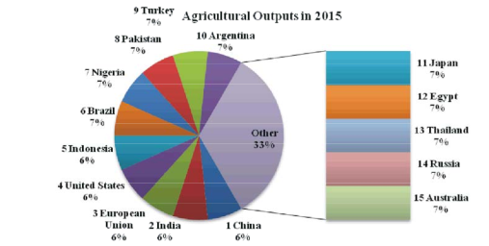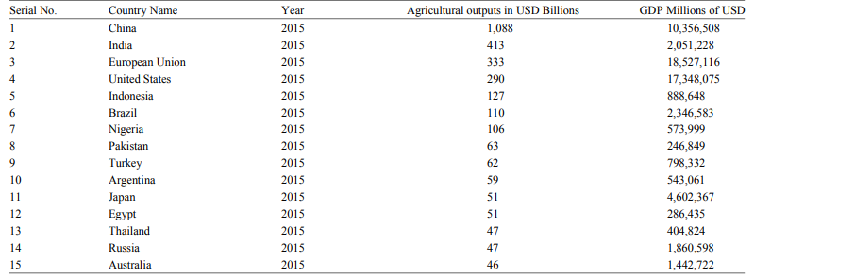Table 1. Top 15 countries in agriculture field [9].

**TECHNOLOGY IN AGRICULTURE:**

**1. Digital Agriculture:** Digital agriculture refers to the integration of new and sophisticated technology into a single system to help farmers & other stakeholders in the agriculture value chain enhance food production. In comparison to traditional and sensor-based approaches, a modern approach known as digital agriculture can assist farmers in understanding their agricultural activities in a far more effective and timely manner. As a result, digital agriculture has a significant impact on crop production enhancements by providing the farmer with the knowledge to execute good scientific knowledge to execute good agriculture practices, as demonstrated in figure 1:

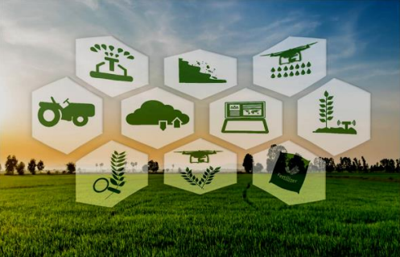

Figure 1. Concept of digital agriculture[1]

The farmer have the ability to share their ideas using the digital agriculture user interface system. This also aids them in learning about various type of cultivation processes used in other parts of the world for the same crop, as well as equipping them with technical developments and business skills to make their agriculture activities a profitable venture. It also gives them the chance to go over prior data in order to better comprehend various scenario and obstacles and obtain the knowledge need to make the best decisions. Agriculture is being transformed by digital technologies and analytics, which are making farmer field operations more insight-driven and efficient. Farmer services based on digital technology are assisting in improving financial performance and increasing production. However, due to the expensive expense of acquiring precise field data, fewer then 20% of land is managed utilizing digital agriculture technologies.

Accenture Precision Agriculture Service and Accenture Connected Crop Solution combine digital technology such as the IOT with big data analytics, visualization skill, and industry experience to assist farmer boost production and profitability[6].Farmer must continue to innovate in order to maintain and improve productivity in order to meet demand in this environment. Farmer may use digital technology to get the information and skills they need to solve these problems and grab development possibilities.

It isn’t only about farmers, though. Consumers in both at home & abroad are getting more knowledgeable about the things they purchase. They seek high-quality, sustainability produced food and fiber, as well as more information about the origins of their purchases. Improved traceability of agriculture products can be achieved through digital technologies, giving consumers’ peace of mind and increasing farmer value.

**Examples of digital technology:**

* Robotics
* New packaging material
* Biotechnology , digital and wireless technology
* Weather monitoring
* Animal monitoring etc. [16].

Agriculture safety is a major problem in the current situation, and it can be addressed by limiting the different toxins that cause crop harm. Field machinery, irrigation system, greenhouse automation, animal automation system, and automation of fruit production system are all examples of agriculture automation technologies that aid in increasing crop yields.

**2. Smart Farming:** Smart farming is a trend that stresses the use of ICT in cyber-physical agriculture management cycle[1]. Smart farming refers to the integration of current information and communication technologies (ICT) with agriculture, resulting in a 4th GREEN RRVOLUTION. Smart farming is a management concept that focuses on providing the framework for agriculture business to employ sophisticated technology- such as big data, the cloud, and the IOT- to track, monitor, automate & analyse activities. Smart farming, often know as precious agriculture, in software-managed and sensor-monitored [15].

A small initiative by John Deere Co. in the year 1990s to user GPS system in tractors linked to the satellite for automated crop map steering, reducing errors and thus increasing crop yield by reducing wastage seeds, optimum utilization of fertilizers and manures, fuel and time paved the way for a full-fledged industry.

**Smart farming technologies:** The intelligent farmer makes use of technologies such as drones and robotics. For more example:-

* **Sensors:** Sensors for soil scanning and management of water, light, humidity, & temperature.
* **Telecommunications:** Advance networking and GPS are examples of telecommunications technology.
* **Hardware and software:** Hardware and software for specific applications, IOT-based solutions, robotics, and automation, as well as enabling IOT-based solution.
* **Data analytics:** Decision-making and forecasting tools as the amount of data accessible from crop yields, soil mapping, climate changes, fertilizer applications, weather data, machinery, and animal heath continues to grow, data collecting is an important aspect of smart farming.
* **Data analytics:** Decision-making and forecasting tools as the amount of data accessible from crop yields, soil mapping, climate changes, fertilizer applications, weather data, machinery, and animal heath continues to grow, data collecting is an important aspect of smart farming.
* **Satellites:** Satellites and drones to collect data for a whole field 24 hours a day, 7 days a week. This is sent to IT systems for tracking and analysis, providing an “eye in the field” or “eye in the barn” that allows for remote monitoring.

According to a poll, 80% of the farmers in the United State and 24% of farmers in the UK have already started utilizing Smart Farming Tools (SFT). The fact that SFT offer value to the farming ecosystem is reflected in these figure. Smart farming methods approaches can be applied to both large scale distributed conventional farming and focused small farming sets of organic farms, depending on the scope of operations [14].

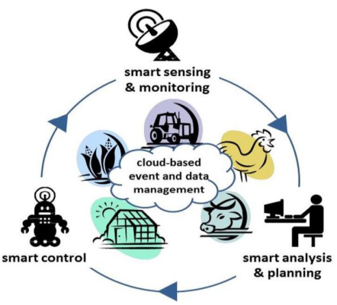

Figure 2. Concept of smart farming [1]

**Benefits of smart farming:** Precision agriculture reduces overall cost & improves product quality, as well as the sustainability of agriculture and the consumer experiences by making farming more connected and intelligent. Increased production control leads to improved cost management and waste reduction. Furthermore, automation improves productivity. Smart agriculture technologies also allow for meticulous demand forecasting and timely delivery of goods to market, reducing waste [13].

**Challenges in smart farming:** According to UN report, the world’s population is anticipated to reach 9.7 billion people by 2050. This means that, given the same natural resources, there will be a significant increase in food demand. It is self-evident that without agriculture advances that boost production and efficiency while maximizing essential resources, this growing demand will not be satisfied.

* **Quality of soil:** The widespread use of chemical fertilizer, herbicides, and insecticides has resulted in a significant reduction in soil fertilizer. The soil quality has deteriorated, resulting in lower growth rates for all crops.
* **Climate change:** As the need for agricultural produce grows, so does the demand for farmland. Forest are cut down to make room for agriculture. Increased temperatures are caused by lack of nature which have a detrimental influence on humans but have considerable greater impact on plants and their growth processes.
* **Consumption of natural resources**:Water, metal, and fuel for agriculture machines are just a few of the natural resources that the agriculture sector consumes.
* **Carbon footprint:** Deforestation for the purpose of obtaining farmland has another drawback: carbon in the atmosphere cannot be used.
* **Decrease of biological diversity:**Deforestation also results in the extinction of a wide range of plants and a reduction in biological diversity. This in turn, has a significant impact on the forest and fauna of the deforested area [12].

**3. E-commerce:** Web-based business necessitates a shift in mind set. It’s a problematic development that’s profoundly altering how people collaborate in the past. Web-based business is similar to buying and selling labour and product over the internet, or even selling assets or information. These transactions are either business to business, business to customer, buyer to buyer, or shopper to shopper. When it comes to value-based cycles in online shopping, the term retail is used. Email, fax, online indexes and shopping baskets, and Electronic Data Interchange (EDI) are all used to direct internet business. The effect of web-based business are now visible in every element of the company, from customer service to new product development.

**Origin of E-commerce:-**

* The case study by Carpio et al. (2013) covers market maker. The authors’ development a market makers producer logic model that depicts long and short-term inputs and outputs. They looked at a variety of business that participate in market makers. They looked at how market makers affected farmers and farmer’s market. They made recommendations for future c-commerce development and evaluation.
* According to Grand View Research, the worldwide B2B e-commerce market was worth USD 6.6 trillion in 2020, and is predicted to grow at a CARGS of 18.7% from 2021 to 2028. In2020, North America will account for roughly 14% of global B2B farm marketplace e-commerce revenue.
* According to Statistic, global retail e-commerce sales reached 4.28 trillion dollars in 2020, with expected to reach 5.4 trillion dollars in 2022.
* The author of Nadarajan and Ismail (20011) talked about the e-commerce framework for rural agriculture and how e-commerce components can be used in agriculture. Six elements of the agriculture e-commerce application wear examined in their research [17].

We were trained to incorporate this E-commerce business into farming because technology is stepping into every industry and assisting each field in its own way. The agriculture market has gotten a lot of attraction, with numerous studies published in publication. Creating a unique platform for farmer allows them to share agriculture knowledge. In today’s, technology may be found anywhere from may be found anywhere from well-equipped cities to a small village. As a result, there are no barriers to adopting technology to enter the e-commerce market. According to the finding of the study, the majority of farmers are not making enough money from their crops. All of the intermediary market techniques are causing huge losses to hardworking farmers. Farmers play an important role in the agriculture life cycle despite their hard work and patience in growing crops, yet they still face a lot of difficulties in making a profit due to their poor circumstance. Agriculture is the key to any country’s entire development. People who transact with agriculture business of any kind are increasingly using the internet. Agriculture employs two-thirds of India’s one-billion-strong population. Currently, the country does not meet the agricultural criteria.

Covid 19’s unresolved public health concern has impacted all areas. Countries must prioritize frontline heath responders in order to save the lives of those who are affected with this disease. Since the coronavirus outbreak, the government has made steps to address the situation. Initially, India announced a 3 week nationwide curfew that would last until the middle of April. How Indian farmer react to the crisis and the government’s attempts to assist farmers across the country in these times. The study’s major is to look into the impact of e-commerce on the agriculture industry during the Covid 19 pandemic.

**What can farmer sell in online:** Some commonly eaten food products that farmers can offer by building an organic products e-commerce platform are listed below:-

* Fruits and Vegetables
* Dairy Products
* Meat & Seafood
* Bakery Products
* Organic Food Products etc.

**Marketing strategy:** Because of the extensive usage of mobile phones, farmers and buyers have become connected. Eat from farms, for example, offers a cutting-edge e-commerce platform via which purchasers may simply place order for items. This system allows customers and sellers to communicate directly, as well as simple speedy purchase and delivery processes.

**Distribution strategy:** Several companies use algorithms to match farmers with buyers based on their requirements and the price at which they are willing to sell. Farmers can either send the food directly to purchasers after sale or use the help of enterprises to transport product from the farm to the final buyer via ecommerce.

**Benefits of Ecommerce in agriculture:**

* Farmer’s efforts can be managed through the use of e-commerce.
* It is a method for farmer to save time by utilizing e-commerce in farming.
* E-commerce aided farmers in their search for machinery that can assist them replace human resource, such as machines for planting seeds, and so on.
* Farmers began to improve their marketing and price exposure.
* Farmers can benefit from a variety of internet trading and e-commerce service.
* Farmers began manufacturing organically produced food as people began to prioritize healthy things.

**Limitation of Ecommerce in agriculture:**

* The expense of upkeep has skyrocketed.
* A scarcity of professionals who can explain how to use e-commerce during a pandemic.
* Because the majority of farmers are illiterate, they are unable to use E-commerce service.
* Managing perishable food got much more difficult.
* Agriculture products didn’t have a proper market place.
* Agriculture methods that aren’t as good as they could be.
* There is a lack of marketing strategies, as well as exposure and cost.
* A lack of enhanced portrayal at various opportunities, establishments, and networking and communication.
* A lack of enhanced depiction at various opportunities, establishments, and platforms, etc.

**4. Big data & data mining:** There are issues that urgently require solutions, and many of those solutions can be found in new technology. Agriculture is embracing big data in a big way. For the proof- Farmers business network, a data analytics firm, just received a $40 million investment from a group of well-known investors. As investors recognize that big data may alter the food chain from farm to table, venture funding has invaded the agriculture tech market, with investment increasing by 80% yearly since 2021.

In the subject of agriculture, data mining tools help to support decision support system (DSS). As indicated in figure 1, the major goal of data mining operations is to extract information from already accessible data sets and then transform it into a unique format that is easily intelligible and can be used for advanced purpose using specific tools.

Data mining aids in soil fertility studies and empowers farmers to decide whether to seed a specific crop type that produce a higher yield. The primary goal of soil classification is to forecast the engineering qualities and fertilizer content of soil in order to prioritize the options for use.

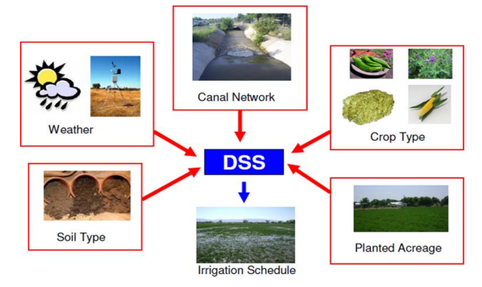

Figure 3:- DSS applied in agriculture[1]

The existing statistical procedures and laboratory tests cost a significant amount of time, energy, and money. It possible to build more efficient strategies for solving difficult and huge soil data sets with more accuracy and effectiveness. Data mining approaches based on GPS, k-means approach, SVMs, and the k-nearest fertilizer method are beneficial for studying soil properties, air pollution, and crop yield determinants.

**Practical application of big data:**

* In the field of meeting the food demand.
* In pesticides use optimization.
* In farm equipment management.
* Supply chain problems management.
* In food safety.
* Tracking environment
* In the cost minimizing sector [18] [11].

Big data also holds a lot of promise for urban framers, who are converting rooftops and vacant lots into small farms. Lloyd Marino of Avetta Global, a big-data expert who has written about seed preservation, points out that, “Big data in conjunction with the Internet of Things can revolutionize farming, reduce scarcity and increase our nation’s food supply in a dramatic fashion; we just have to institute policies that support farming modernization” [7].

Farmers, food handlers, grocers, and the general public should have free access to data. Both consumers and farmers must have faith in the data, so how and why it is obtained should be transparent. To get the most out of agro tech, farmer need smart practices, new infrastructure like smart highways, and a revamp of communications infrastructure that wasn’t meant for near-constant wireless input. Agriculture robotics research should be bolstered in order to develop robots that can respond to data in order to produce better, faster, and more efficiently.

**Data in the future of smart farming:** For the longest time in history, our collective judgments wear mostly based on instincts or best guesses. Precision has never been a luxury afforded to humans, which is why big data plays such a vital role in agriculture. Big data can ensure that farming remains a stable and viable line of work for farmers by reducing variables and allowing producers to keep on step ahead of their ecosystem.

**Future of big data in agriculture:** Big data agriculture has a bright and promising future ahead of it. The agriculture big data analytics industry alone in expected to reach 14 billion USD by 2025, indicating that the segment is generating a lot of interest. It’s critical to strengthen the analytical capacities of machine learning and AI system in order to take this step in to the future. There’s no telling how huge the impact on agriculture, smart farming, precision farming, and the economy in general once these software are fine-tuned for big data analytics.

**5. ICT in agriculture:**ICT encompasses all digital technology applications that exist to assist individuals, corporations, and organizations in making informed decisions. ICT refers to any device that can store, retrieve, alter, transmit, or receive data in a digital format. Information and Communication Technology (ICT) is defined by the World Bank as “any device, tool, or application that permits the exchange or collection of data through interaction or transmission”. It “includes anything ranging from radio to satellite imagery to mobile phones or electronic money transfers” (Anonymous, 2011c) [8].

Every day, farmer make judgements in a variety of risk and unclear scenarios. These decisions will have to be made based on the information that available at the time. Access, efficiency and affordability of agricultural information continue to be a major impediment for raising agricultural productivity among smallholders in the developing Countries (Muriithi et al., 2009) [8].

ICT can play a critical role in this field by delivering information to farmers and assisting them in making better, more informed decisions. The demand for information is especially acute in the context of globalization agriculture. Smallholders, who still provide a significant portion of the world’s food, need information to advance their work just as much as industrial-scale producers. (Anonymous, 2011b) [8].ICT can aid in the removal of numerous obstacles in agriculture. For starters, there aren’t enough extension facilities. Second, there is the problem of illiteracy among farmer. Thirdly, farmer’s ability to compete with large farmers is constrained. Fourth, the divide between ancient and contemporary technology is expanding. Finally farmers are cut off the most up-to-date information.

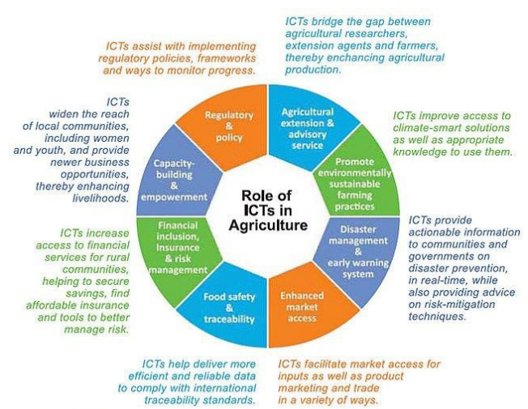

Figure 4. Role of ICT in agriculture [8]

**Information needs for the farmer:** According to a national survey of farmer conduct by NSS, only 40% of farmer families have access to information about contemporary agriculture techniques and inputs. From the table 1 we can see:-

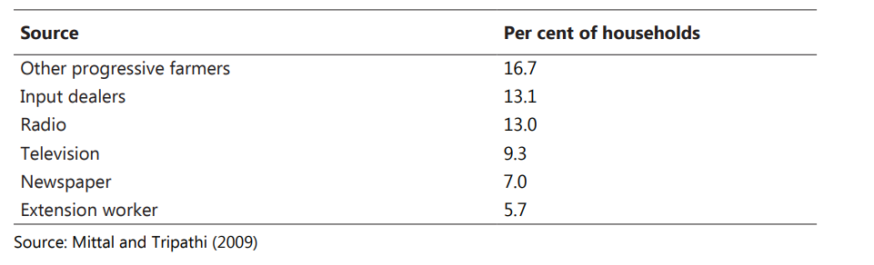

Table-2. Source of agriculture used by farmer[8]

The following are some of the benefits of ICT in agriculture-

* ICT and agriculture facilities improved farmer productivity and profitability.
* Resource consumption and management that is efficient.
* The farmer receives timely rain and other crucial information.

**6. Mobile & Agriculture:** The application of mobile technologies to support actor along the agriculture value chain is known as mobile agriculture (m-AGRI). Mobile technology encompasses a subcategories such as voice, data, network and connectivity. The term m-Agriculture refers to a subset of the term e-agriculture [17].

Agriculture is the primary source of revenue in the majority of developing countries. Low yields, farmer stress, and low income result from a lack of access to essential information. Nowadays, information and communication technologies have the potential to alter agriculture in rural areas. Smartphones and their applications have brought with them a slew of new features. The applications have been developed to help farmers reduce stress; acquire relevant information on good agriculture practices, weather, quality input, markets tendency, etc. [8]. Farmers may use their smartphones to enhance their ability, share their experiences, and even sell their products online via social media, websites, and other application.

Many farmer are able to carry out their daily tasks with the help of mobile app. When it comes to agriculture, the introduction of mobile apps has yielded numerous benefits, ranging from improved land management decisions to higher output quality. Farmers have even begun to use a variety of mobile applications to monitor of mobile applications to throughout the crop cycle. There are also some of the most recent smartphone apps that are being utilized to make important farming decisions such as fertilizer and pesticides use. Farmer now have the option of making decisions based on sophisticated outcomes rather than intuition or tradition.

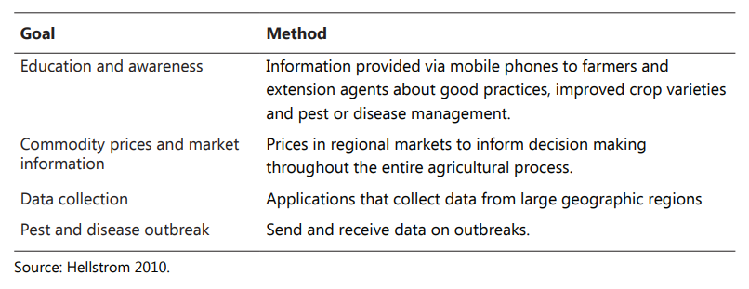

Table-3. Various roles for mobiles in agriculture [8]

Smartphones and their applications are technologies that provides an excellent answer for agricultural development by allowing farmers to access pertinent information. It contributes to the enhancement of agricultural extension and advisory services. Farmer may now more efficiently thanks to the introduction of mobile application development. They also play a significant influence in minimizing the associated costs. Farmer can use mobile app to grow better crops, resulting in increased revenue and improved livelihoods.

**7. Microsoft Cortana:** Microsoft AI is assisting Indian farmer in increasing crop yields. Microsoft has created an AI-Sowing App using Microsoft Cortana Intelligence Suite in conjunction with ICRISAT. AI, Cloud Machine Learning, Satellite Imagery, and advanced analytics are enabling small-holder farmers in India to boost their revenue by increasing crop productivity & controlling prices. Farmer in a few dozen villages throughout Telangana, Maharashtra, and Madhya Pradesh are receiving automated phone calls informing them weather their cotton crops are at risk of insect attack based on weather and croup stage[16]. The customised village advisory dashboard was created specifically to help administrators better manage large-scale activities. Using powerful bi tools, this dashboard provides important insights around soil health, fertilizer recommendations, and seven-day weather forecasts derived from the world’s best available weather observations systems and global forecast models. This data is then downscaled for the highest possible accuracy at the village level, to transform how small holder farmers tackle climate change to drive effective decision-making for their crops [4].

The software sends out sowing tips to participating farmer on the ideal time to seed, and the greatest things is that they don’t have to place any sensors in their fields or spends any money. “All they need is a feature phone that can receive text message,” according to the company [4].

**8. Autonomous Farming:** Agriculture is at the heart of a slew of different sectors. It has a global revenue of more over 2 trillion dollars. Farming, on the other hand necessitates continual monitoring of crops, soil nutrients, and other factors. Thankfully, there are more efficient alternatives to human labour for agriculture maintenance, particularly for bigger enterprises. The way we changing s a result of autonomous agriculture. Crops are healthier, and farmers are getting a better return on their harvests.

Autonomous agriculture is a facet of the larger precision agriculture movement. Precision agriculture is the practice of using fine-tuned calibrations and technology to make farming more efficient. Autonomous agriculture allows farming equipment such as tractors to operate without a human driver. Technology such as the Trimble BX992 and similar equipment allow for remote control use and monitoring of farm equipment. More and more farming operations are using autonomous agriculture technology to gain an edge in the global market [15].

* Farming labour shortages could be alleviated with use of autonomous tractors.
* Other advantages include drones and seed-planting robots.
* By 2027, the market for autonomous farming equipment is expected to reach $95 billion.

Agriculture drones, self-driving tractors, and seed-planting robots are just a few of the advances that could be critical to future food supplies, as autonomous farming promises to produce more crops with less work and less environmental damage. According to the Agriculture and agro-food labour task force, labour shortages in Canada’s farming industry might reach 114,000 by 2025. A small situation exist in the USA, which fluctuations in immigration number have resulted in a labour shortage in the agriculture sector.

**Autonomous Agriculture Equipment:** Autonomous farming makes use of cutting-edge technologies. Several system will need to be installed and coordinated for best efficiency. The following are examples of those system:-

* **Soil Sensors:** Sensors installed on the farm will track the health of soil and crops. Sensors can also be used to track weather changes and make adjustments to water and nutrient schedules and amounts as needed. Farmer will be notified of any changes in real time via their workstations or cell phones. The capacity to major advantage of sensor.
* **Autonomous Tractor:** Autonomous tractors, like sensors, allow a farmer to roam around freely while still managing seeding, soil, and crops. Based on sensor data or farmer input, an autonomous tractor will spread fertilizer and seed to the places that need them the most. New GPS tractors and sprayers can drive themselves through the field with pinpoint accuracy, eliminating the need for a human. A user has specified how wide a path a certain piece of equipment will cover on the computer system's board, and he will drive a short distance to establish A and B locations to form a line [9].
* **GNSS:** Most forms of autonomous agriculture need the use of global navigation satellite system. A GNSS keeps track of the location and driving habits of farming equipment, as well as keeping well. Getting access to a GNSS in as simple as connecting Bluetooth after having the necessary equipment.
* **Agricultural Robot:** Annie, an Agriculturalrobot from the future! Trimble’s autonomous navigation skill are approach to assisting farmers in overcoming the most pressing difficulties in agriculture [14].

**9. Ultrasound & sensors for livestock:** Ultrasound sensors measure distance by emitting ultrasonic waves and have wide range of application, including fluid monitoring and object recognition. Heavy equipment sensors are utilize in the commercial industry to increase safety by alerting operators to impediments and moving vehicles in their near vicinity. The use of ultrasonic detectors for level measurement, fertilizer application, and crop monitoring is all part of agriculture sensor technology [13].Irrigation system and soil parameters are also monitored with agriculture sensor. Overwatering and under watering damage crops, hence ultrasonic agriculture sensors can be employed to monitor irrigation system. Agriculture sensor technology can be used to monitor and manage the application of herbicides, insecticides, and fertilizer in the soil.

In agriculture, effective application of fertilizers and pesticides remain a major difficulty, particularly when it comes to determining which fertilizer is appropriate for different crops, when to apply it, and in what quantities. Crop sensor can make it simple for farmer to apply fertilizer and insecticides exactly as needed by their crops. In such situation, variable rate technology comes in handy. This technology allow farmers to sense how plant is feeling and, as a result, assist then lessen the likelihood of leaching or surface runoff [10]. Crop sensors are constructed in such a way that they tell the application machinery how much resource a certain crop has and when it needs it. Based on the amount of light reflect back to the sensor, the optical sensor may determine how much fertilizer a plant needs [9].

**Advantage of using digital farming methodology:**Most difficult project for agriculture science nowadays is to make certain for non-stop & sufficient supply of meals for developing human civilization. Urban facilities in the course of the world have experienced good sized growth in population; this increase is accompanied by trade in meal habits and rising concern for meals great. Hear, food fine refers to the most beneficial stages of the nutrition inside the meal along with the minimized quality of the chemical (pesticides /fertilizers) resides used within the production of the crop. Successful agriculture transformation, internationally, has been in large part attributed to improved farm technology consisting of fertilizer, progressed seeds and soil and water conservation (Gabre-Madhin and Johnston 2002). Further, to satisfy the big meals grain requirement of 480 million tones in India by means of the year 2050, with the increasing undertaking of biotic stresses experienced with the aid of plants, the advent and adoption of the current generation in Indian agriculture is inevitable (Bisoyi 2006)[3].

Both on the farm and in the industry, there are advantages to digital farming. The impact can be seen in farming. The impact can be seen at the micro-level, beginning with a signal farm, and progressing to the macro level, impacting international legislation. Top benefits for farmers include:-

* Management and decision-making progress have improved.
* More target applications resulted in increased efficiency.
* Marketing has improved.
* Information that is current.
* Innovations in record-keeping.
* Risk and uncertainties are managed.
* A decrease in the regulatory load [11] [12].

By eliminating paper forms and data collecting, digital farming, for example, boosts productivity and information. Mobile forms and a database that stores agriculture data have taken their place. Data collected in the field can be transferred to the central office or directly to clients in real-time, boosting communication accuracy.

As farmers achieve better environmental outcomes, the ripple effect continues to develop. With improved collaboration and learning, there is an impact at the international level. Stakeholders are concerned about the impact on agriculture around the world [12].

**The disadvantage of using digital farming methodology:**

Techniques are still in development, it is critical to get expert counsel before making costly decisions.

* Overuse of machinery has the potential of harming the environment.
* It is effective, but it comes with a slew of advantages and adverse effects.
* Furthermore, access to the technology is hampered by the use of driverless agriculture machines.
* Scouting programs should be improved.
* Because the majority of farmers are illiterate, they are unable to operate sophisticated machinery [11].
* Because initial capital expenses are likely to be substantial, it should be considered a long-term investment [26].
* It could take several years to gather enough data to properly implement the system.
* Work that extremely taxing, especially when it comes to data collection and analysis [17].

**Conclusion:** Farming is a way of life, not just a profession. Food is one of the most important sources of life, but the farmers who produce it are unable to meet their needs. Farmers in the country are currently dealing with a variety of agricultural difficulties. During our research, we discovered that there are ample the method to use in digital technology to assist farmers.

Digital agriculture, precision agriculture, agriculture yield analytics, and other applications of technology in agriculture have resulted. Agriculture employs a big number of people in India, and there is a technology divide between farmers and technology. Modern agricultural technology was created with two goals in mind: the first is to achieve the largest yields feasible, and the second was to achieve the highest economic profit possible. Application of inorganic fertilizer, irrigation, intense tillage, monoculture, chemical pest control, and enatic manipulation of crop plants are six essential practices that have become the backbone of agriculture production to attain these aims. The government have established a variety of agricultural practices to assist farmers in taking advantage of technology. Despite this, there is room for user-friendly, simply understandable agro advising systems to assist farmers in making crop-sowing decisions.

**Reference:**

[1] R. S. Upendra, I. M. Umesh, R. B. Ravi Varma, and B. Basavaprasad, “Technology in Indian agriculture – A review,” *Indones. J. Electr. Eng. Comput. Sci.*, vol. 20, no. 2, pp. 1070–1077, 2020, doi: 10.11591/ijeecs.v20.i2.pp1070-1077.

[2] J. Goedde, L; Katz, J; Menard, A; Revellat, “Agriculture’s technology future: How connectivity can yield new growth | McKinsey,” *McKinsey Co.*, no. October, p. 10, 2020, [Online]. Available: https://www.mckinsey.com/industries/agriculture/our-insights/agricultures-connected-future-how-technology-can-yield-new-growth#

[3] K. Shruthi, G. M. Hiremath, and A. T. Joshi, “An overview of use of precision farming technologies by the farmers- A case study of North Eastern Karnataka,” *Indian J. Agric. Res.*, vol. 52, no. 1, pp. 93–96, 2018, doi: 10.18805/IJARe.A-4889.

[4] D. Goel and G. Devi, “A Review on Impact of Viral Marketing,” vol. 3, no. October 2018, pp. 1–8, 2014.

[5] D. C. K. Gomathy, “A Study on Ecommerce Agriculture,” *Int. J. Res. Appl. Sci. Eng. Technol.*, vol. 9, no. 10, pp. 1486–1488, 2021, doi: 10.22214/ijraset.2021.38648.

[6] V. F. Report, “Digital Agriculture,” *Encycl. Big Data*, pp. 383–383, 2022, doi: 10.1007/978-3-319-32010-6_300087.

[7] S. T, “How Big Data And Tech Will Improve Agriculture, From Farm To Table,” *Forbes*, pp. 1–5, 2017, [Online]. Available: https://www.forbes.com/sites/timsparapani/2017/03/23/how-big-data-and-tech-will-improve-agriculture-from-farm-to-table/#3f6a5ca65989

[8] A. Nagesh, S. Raj Director, and N. Lenka Disclaimer, “National Institute of Agricultural Extension Management (MANAGE) About the Publication Layout Design,” pp. 1–52, 2019.

[9] A. Rehman and I. Hussain, “Modern Agricultural Technology Adoption its Importance, Role and Usage for the Improvement of Agriculture province, Pakistan View project Eco-energy-environmental nexus in China View project,” vol. 16, no. February, pp. 284–288, 2016, doi: 10.5829/idosi.aejaes.2016.16.2.12840.

[10] C. M. Jolly and H. A. Clonts, “Farm Management,” *Econ. Aquac.*, pp. 141–190, 2020, doi: 10.1201/9781003075165-9.

[11] *THE IMPACT OF BIG DATA IN AGRICULTURE*. (2021, January 7). Retrieved from analytics insight: https://www.analyticsinsight.net/the-impact-of-big-data-in-agriculture/

[12] *The challenges that smart agriculture technologies successfully combat*. (n.d.). Retrieved from Smart Farming Solution: https://ondo.io/the-challenges-that-smart-agriculture-technologies-successfully-combat/

[13] Bernstein, C. (n.d.). *smart farming*. Retrieved from TechTarget: https://www.techtarget.com/iotagenda/definition/smart-farming#:~:text=Smart%20farming%20is%20a%20management,monitoring%2C%20automating%20and%20analyzing%20operations

[14] *What is Smart Farming — Everything you want to know about it.* (2019, August 26). Retrieved from Medium: https://medium.com/@emorphis.technologies/what-is-smart-farming-everything-you-want-to-know-about-it-28e0e5d8e142

[15] *What is digital agriculture?* (n.d.). Retrieved from Agriculture Victoria: https://agriculture.vic.gov.au/farm-management/agtech/what-is-digital-agriculture

[16] *E-commerce*. (n.d.). Retrieved from Britannica: https://www.britannica.com/technology/e-commerce

[17] *Precision Farming Next*. (n.d.). Retrieved from adlib. everysite: http://adlib.everysite.co.uk/adlib/defra/content.aspx?id=000IL3890W.16NTC0M9SDC2MO.